Contents

LAN Design Plan for Callme 2

Design blueprint of callme LAN 2

Implementation of callme LAN 3

Requirement of devices, Justification and Improvements to LAN 4

First floor networking devices; 4

Second floor networking devices; 4

Third floor networking devices; 5

Test plan 6

Simulation test 6

Ping test 7

Traceroute test 8

# LAN Design Plan for Callme

Step 1: Obtain a complete outline of the company’s plan and what computers are available.

Step 2: Analyze said plan and strategically perform a rough sketch to develop a simple network for the given outline.

Step 3: Use the rough sketch as a base and use Packet Tracer to logically place all the clients and the servers of the network.

Step 4: Research on what routers, switches and other network devices are available in Sri Lankan warehouses.

Step 5: Now logically place routers, switches and important other network devices in the blueprint.

Step 6: Run a simulation test to see if packets are being transmitted through clients.

Step 7: Test if the simulation test has any **clients** that do not receive packets.

Step 8: Finalize the blueprint and begin writing the network plan.

# Design blueprint of callme LAN

First, second and third floor in order.

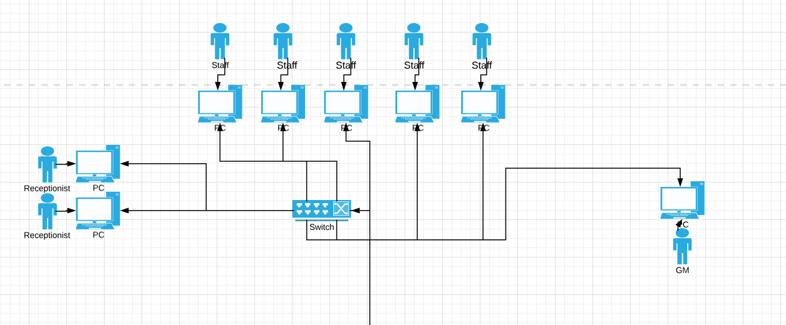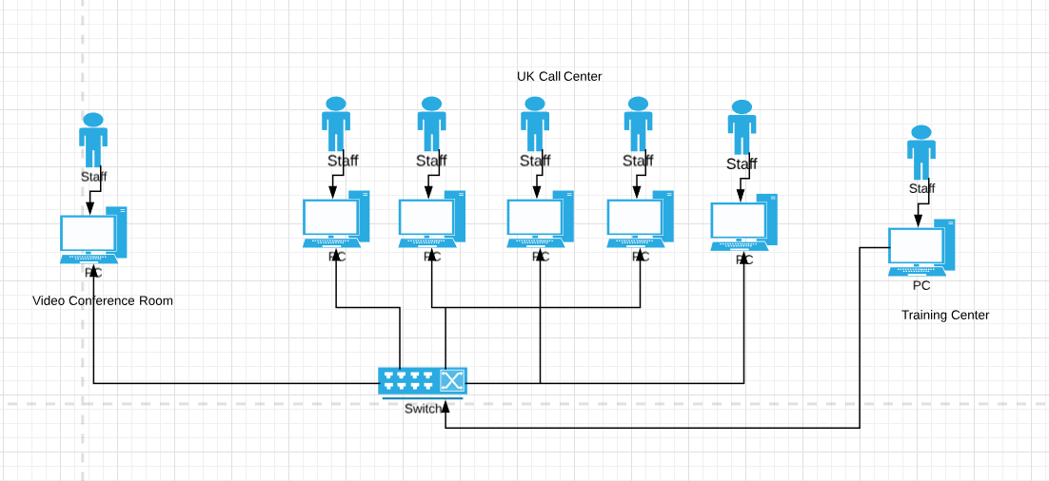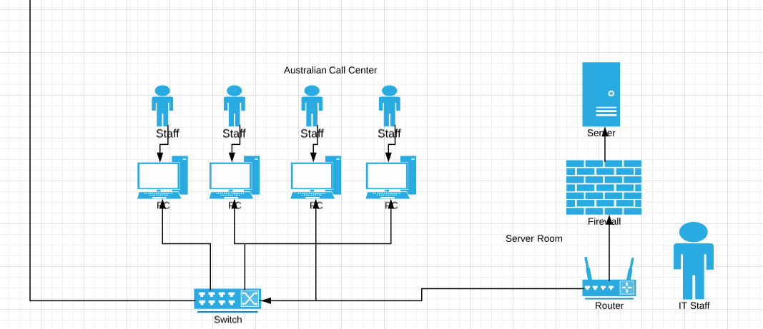

# Implementation of callme LAN

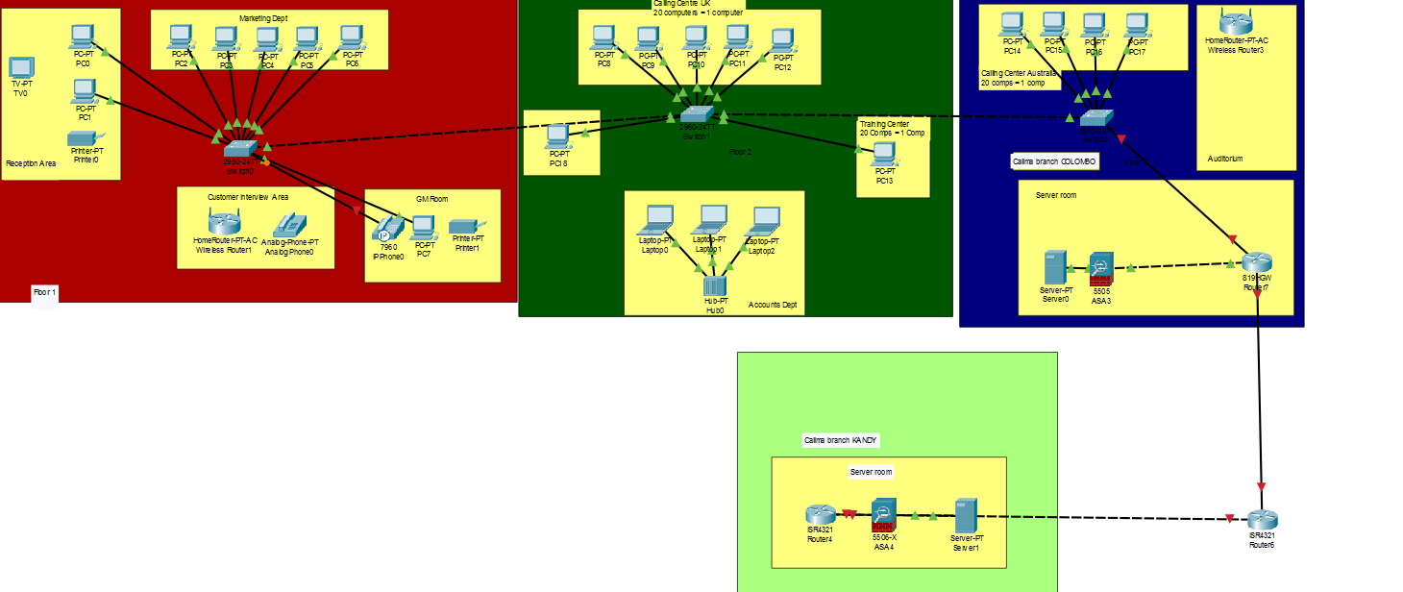

Red: First Floor

Dark Green: Second Floor

Blue: Third Floor

Light Green: Kandy branch

# Requirement of devices, Justification and Improvements to LAN

RJ45 cables: Can be bought at <https://mmsrilanka.com> with 950 LKR per 10 meters

## First floor networking devices;

16 port level 3 switch: D-Link 16Port DGS-1016A Level 3 Switch at LKR 12,150.00, which can be bought at <http://www.barclays.lk> after contacting sales department. This switch is recommended for small scaled business in Sri Lanka.

Reason: 16 port switches is used because 9 of the ports have been used and in case the number of clients in the 1st floor increases, the switch doesn’t have to be replaced. A level 3 manageable switch due to necessity of connecting switches in between and for VLAN configuration.

In the 1st floor, the marketing department is configured to have a VLAN. The outline states that 10 employees work in the marketing division, in order to cut down cost and save time I propose that the batch of 10 is split into 2 and they work in shifts on the computers.

There are 2 networked clients on the reception area in order for the receptionists; a printer has been placed alongside them in case they need to print invoices, documents, bills etc.

The customer interview area has been purposely decentralized as this area is a probable area from which threats to the security of the network can arise from. A home ADSL router has been placed to guarantee WiFi.

The wifi router is recommended to be bought from your chosen ISP.

I propose using Dialog due to their smart plans and high speed internet. They also provide 4G routers alongside the subscription to their servers.

The GM room has an IP phone connect to the network in case the GM has calls with international lines, this could help cut down costs and a probable improvement is implementing IP phones in the calling centres as well.

IP phones can be bought alongside services from 3CX at <http://fennix.lk/3cx/> a Sri Lankan 3CX provider.

The computer placed in the GM room is also networked.

## Second floor networking devices;

3x 48 port level 3 rack mountable switches-TPLink: 48-Port 10/100Mbps Rack mount L3 Switch- TL-SF1048 at 21,560.00 LKR per each.

A total of 144 ports will be available out of which 121 ports will be used, the excess ports are for the probability of upgradability in the future. There is a total requirement of a definite 120 clients so this switch is the idea, it fires at 10~100Mbps and is rack mountable which allows for better usability which you can buy at <https://mmsrilanka.com/>. This switch is recommended for small to medium scaled business in Sri Lanka.

The accounting department has been decentralized as requested and contains 3 laptops for each employee networked separately by a 4 port Ethernet hub for any necessity of communication between the laptops. The accounting department has been equipped with laptops so that locational flexibility is ensured.

Netgear (EN104TP) 4-Port 10 Mbps Ethernet Hub RJ-45 with Uplink Button can be bought at <https://www.ebay.com> for 14,202 LKR. A possible improvement is that the accounting department is centralized and connected to one of the 48 port level 3 switches but be assigned to a VLAN of its own, for additional security purposes, surfing the internet can be restricted, activity can be monitored, antimalkware and virus guards like MalwareBytes or AVG can be installed and sensitive information can be rigorously encrypted using AES 256 bit in GCM mode, with a 24 character alphanumeric key that is auto generated.

The video conferencing room has been only equipped with 1 client as the outline does not state the exact goal of this room and what functions it performs other than the obvious video conferencing, this installation is however vague so I propose disconnecting this client from the network if there is no necessity for video conferencing to have any relationship with the network. For video conferencing across countries, I personally recommend Skype due to their backing by Microsoft and their high quality.

## Third floor networking devices;

2x 48 port level 3 rack mountable switches-TPLink: 48-Port 10/100Mbps Rack mount L3 Switch- TL-SF1048 at 21,560.00 LKR per each.

Out of the 96 ports available 81 will be used. As per the afore mentioned benefits of using this switch, a particular advantage arises from using this same switch in the 3rd floor as well, as companies allocate discounts when you buy these switches in bulk also if an error occurs be it physical or virtually it will be very easy to troubleshoot.

Server: PowerEdge T630 Server with Intel Xeon E5-2620 v4 2.1GHz and 16GB RDIMM, 2400MT/s, Dual Rank RAM, the server comes with 600GB but I suggest installing additional HDDs or buying a cloud storage from Azure(which has distributors in Sri Lanka). This server can be bought at NEAT technology, call them at +94 115 565 000 and reserve this server at 592,250.00 LKR with 3 years warranty period. It is extremely powerful and can withstand any and all demands in the company. I recommend buying the same server for the kandy branch as well.

For hardware firewall solutions, I recommend contacting techgates at +94 115 813 513 and arranging for a firewall service, they provide hardware firewalls from KerioControl based in the European region and is one of the most affordable firewalls in Sri Lanka. This service comes with full navigation, control, restriction, user based access control and traffic sharping technologies. They offer deployment in software or hardware level, but as XYZ is an insurance company, it is recommended to have a hardware firewall.

A possible improvement is replacing the firewall with a router that has an integrated firewall with it, this is the ideal solution for high-end networks. The management can discuss and go for a router like this, I could recommend the Cisco 3000 firewall+vpn+routing capability.

For the routers placed in the 3rd floor plan, the logical implementation somewhat ideally shows that it is arranged in an IPsec structure between the Colombo and kandy branch. Arrange for an IPsec service from your ISP and they will provide your Colombo branch and kandy branch 2 routers, the router placed in the middle is not a company router, it is owned by the ISP.

The firewall has been placed after the router and before the server so that any and all traffic to the server is strictly monitored and identified. I suggest using WireShark, which is a packet sniffer that can help analyze all the packets that enter and leave the server. This can be proven to a solid way of monitoring the security of the server.

The server however must be installed with Windows Server 2012, by Microsoft and equipped with the business plan of MalwareBytes to scan for malware, spyware and rootkits regularly.

The justification contains possible improvements to the plan so the test plan will not describe any of it. I believe this way there is more insight and valuable scope defined.

# Test plan

1. Simulation test to check if packets are shared across the clients in the network: Successful on all clients

Expected simulation test to fail in the UK call center, but it didn’t.

1. Ping test to check if simulation test was accurate: Successful, therefore simulation test is accurate.

Due to my expectation of simulation test to fail in the UK call center, I had to check PC9 to PC10 with a ping test to see if packets are shared which helped proved that simulation test is accurate.

1. Trace route test from IP 192.168.0.4 to 192.168.0.2: Successful therefore routing of packets is accurate.

Expected multiple hops but only received 1.

## Simulation test

**Successful**

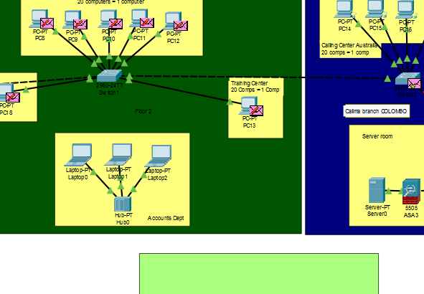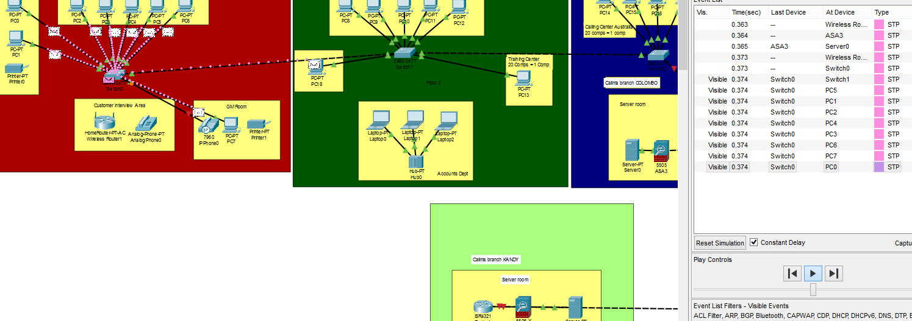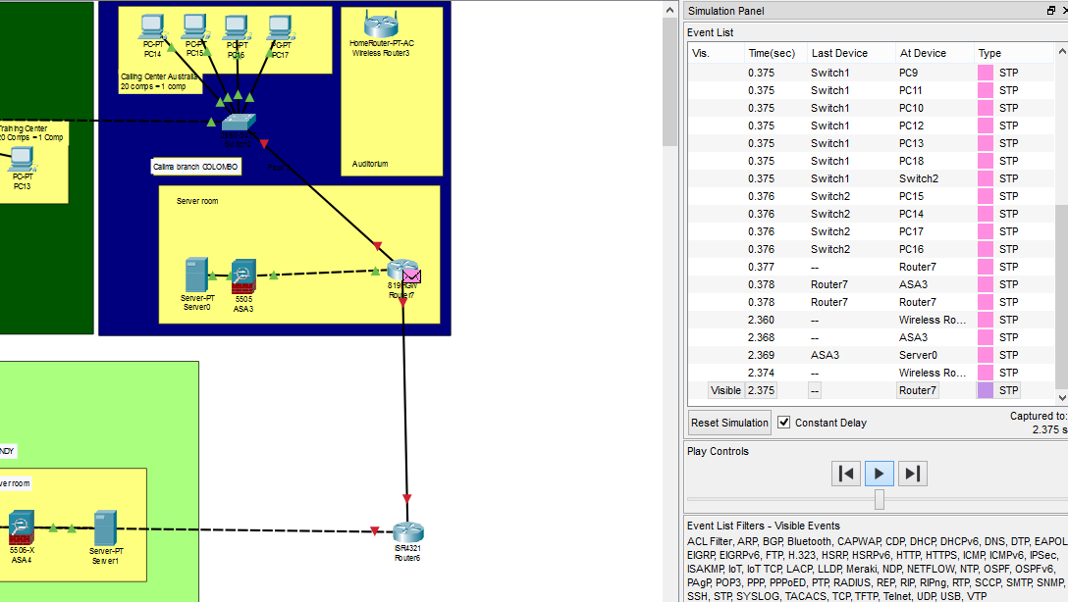

## Ping test

**Successful**

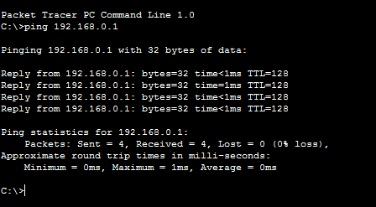

## Traceroute test

**Successful**

